Optimising the Price of Utilities over 24 hours

# Introduction

This study developed several models that optimise daily demand to enable customers to manage their electricity and gas consumption effectively based on an objective – price or carbon intensity. Increasing electrification and a societal paradigm shift towards using localised, renewable generation has resulted in peaks of demand growing and due to intermittent nature of renewables, there are mismatches in supply and demand. Thus, incentivising customers to shift their electricity usage elsewhere not only lowers their costs but also aids in reducing faults on the power network [1].

# Optimising Electricity and Gas for Cost

## Mathematical Formalisation of Electricity Problem

The problem may be approached using traditional minimisation linear programming techniques such as the dual simplex algorithm – implemented in MATLAB’s optimisation toolbox - although simple greedy heuristics will yield the same solution in this scenario. The decision variable represents the electricity demand (kWh) and the cost (p/kWh VAT included) at discrete half-hour interval . Constraint (2a) imposes an upper bound on the demand per interval , and (2b) states that the total demand across the 48-hour timeframe must be equal in the optimised and original scenarios (original demand is given by  ). Demand is assumed to take real values.

(1)

**subject to**

(2a)

(2b)

(2c)

## Mathematical Formalisation of Gas Problem

The gas optimisation problem formulation is identical, except for constraint (2a) which needs to be modified to reflect the restriction of a maximum demand of 1.3 kWh per interval – shown in (3a).

(3a)

## Testing and Results

Model fitness was tested using a range of conditions shown in Table 1. These conditions consider the half-hour (HH) maximum limit, whether the total demand is met, and if the model saves the customer money.

Table 1: Testing cost optimisation

|  |  |  |  |  |
| --- | --- | --- | --- | --- |
| Model Type | Optimal HH electricity demand 4 kWh? | Optimal HH gas demand 1.3 kWh? | Daily demand satisfied?  (demand before = optimal demand) | Savings made (p)  (demand cost– optimal cost) |
| Electricity Model | Yes | N/A | Yes | 147.0-101.7 = 45.3 |
| Gas Model | N/A | Yes | Yes | 5.0-5.0 = none |

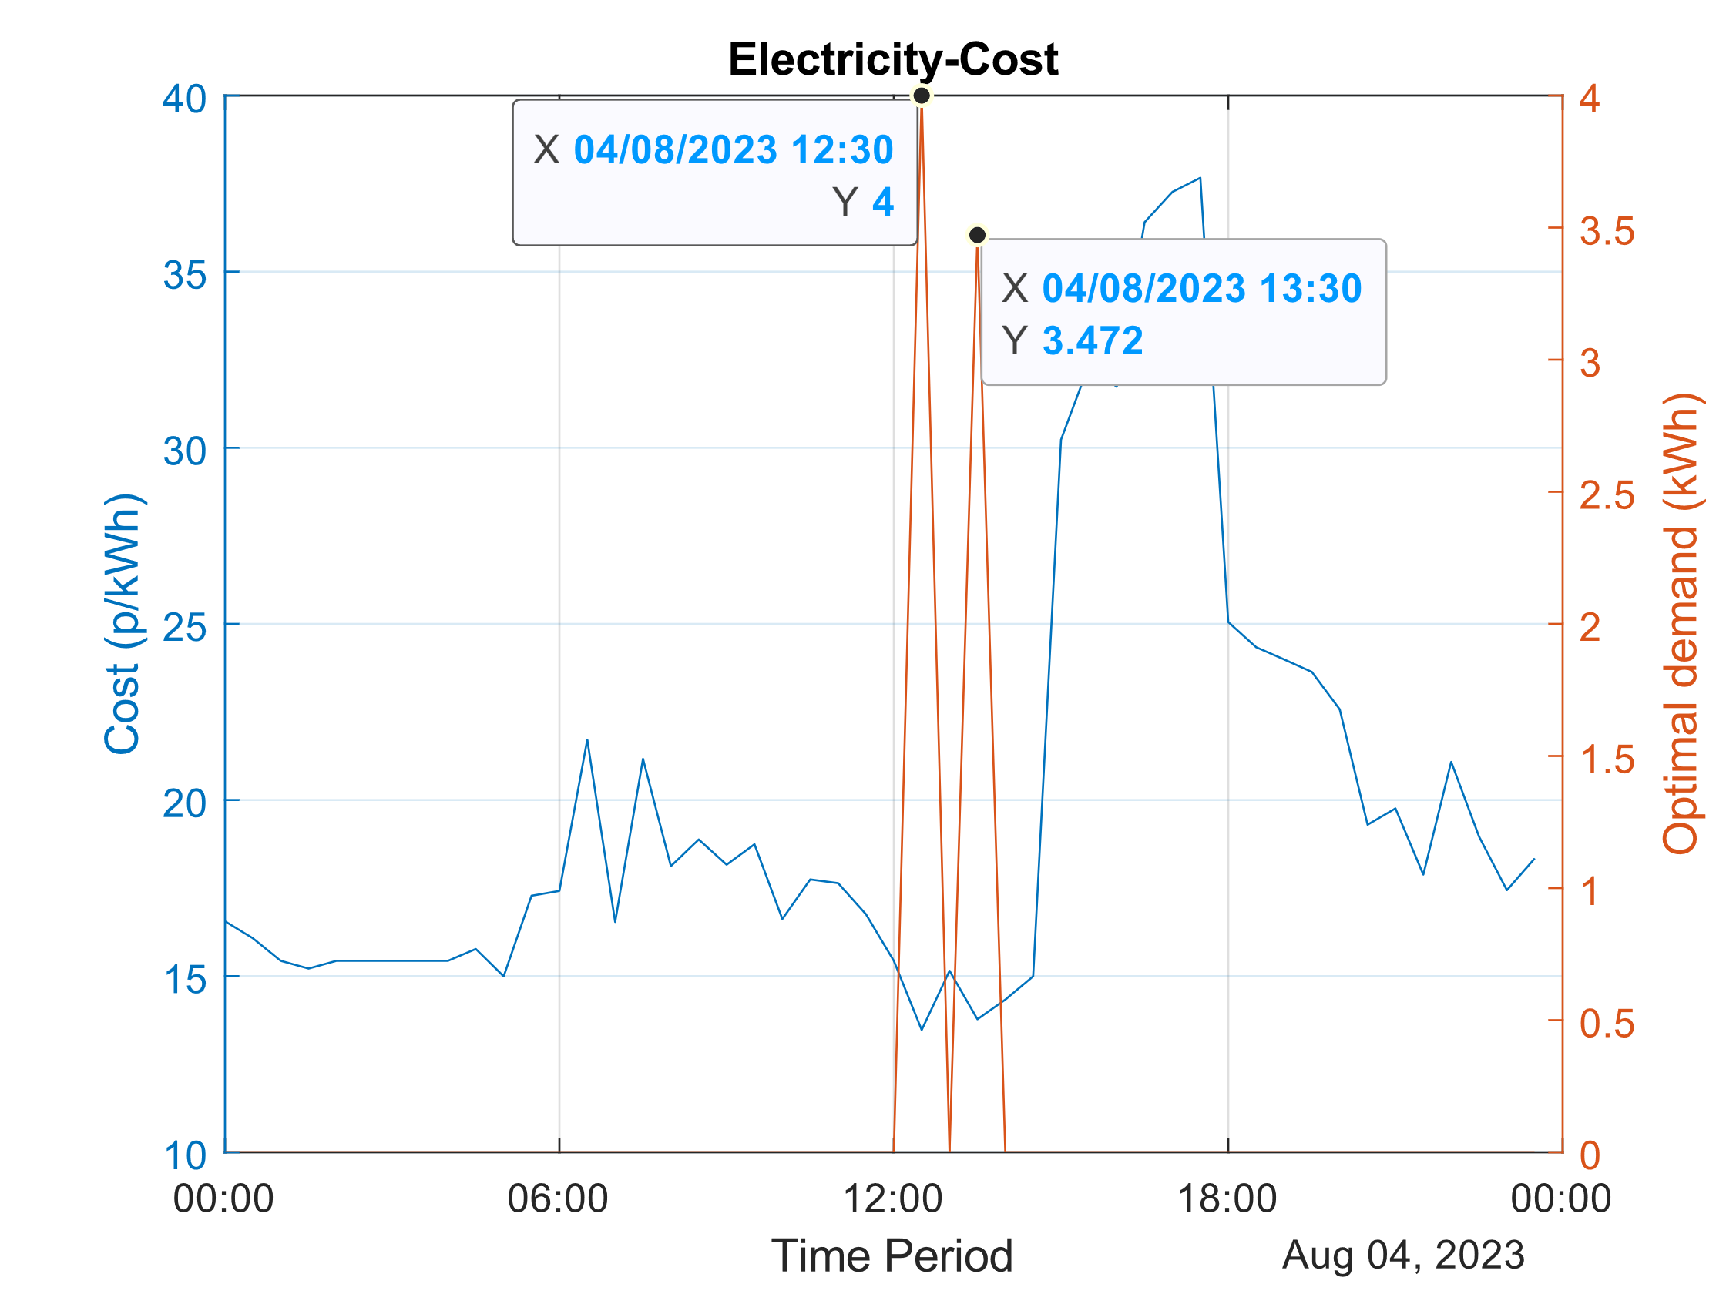 Further testing, and confirmation of results, entailed visual inspection of the plots displayed in Figure 1. This aligns with the results in Table 1 and confirms that the model is optimised for cost – since the demand is at its peak when cost is lowest. For the gas-cost model, the optimal demand occurs almost instantaneously as the cost constraint remains constant demonstrating a model with multiple optimal solutions, but only one optimal value.

Figure 1: Optimising electricity cost

# Optimising Electricity and Gas for Carbon Intensity

Optimising for carbon efficiency adopts an identical mathematical formulation to the original problem except for the objective function – which now minimises carbon intensity rather than economic cost (i.e. now refers to carbon intensity). There is a strong correlation between low price and low carbon intensity, explained by the increasingly affordable nature of clean energy sources. [2]

## Testing and results

Table 2: Testing carbon emissions optimisation

|  |  |  |  |  |  |
| --- | --- | --- | --- | --- | --- |
| Model Type | Optimal HH electricity demand 4 kWh? | Optimal HH gas demand 1.3 kWh? | Daily demand satisfied? | Reduction in carbon intensity (kg)  (carbon intensity before– optimal carbon solution) | Price reduction (p/kWh) |
| Electricity Model | Yes | N/A | Yes | 1.08-0.6343 = 0.4457 | 9.21 |
| Gas Model | N/A | Yes | Yes | 0.1486-0.082 = 0.0666 | 0 |

Like the cost model, Figures 2 & 3 exhibit correct behaviour for carbon emission optimisation where the HH limits are respected, and demand is invested when the carbon intensity is lowest.

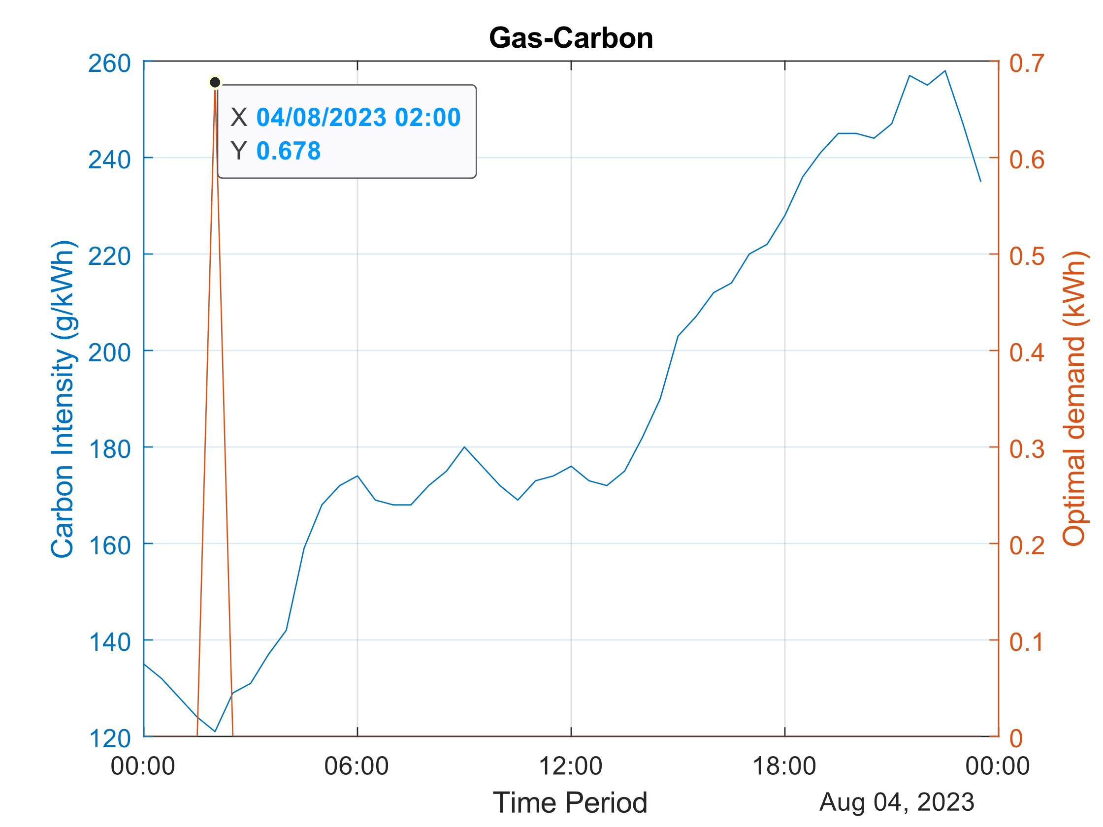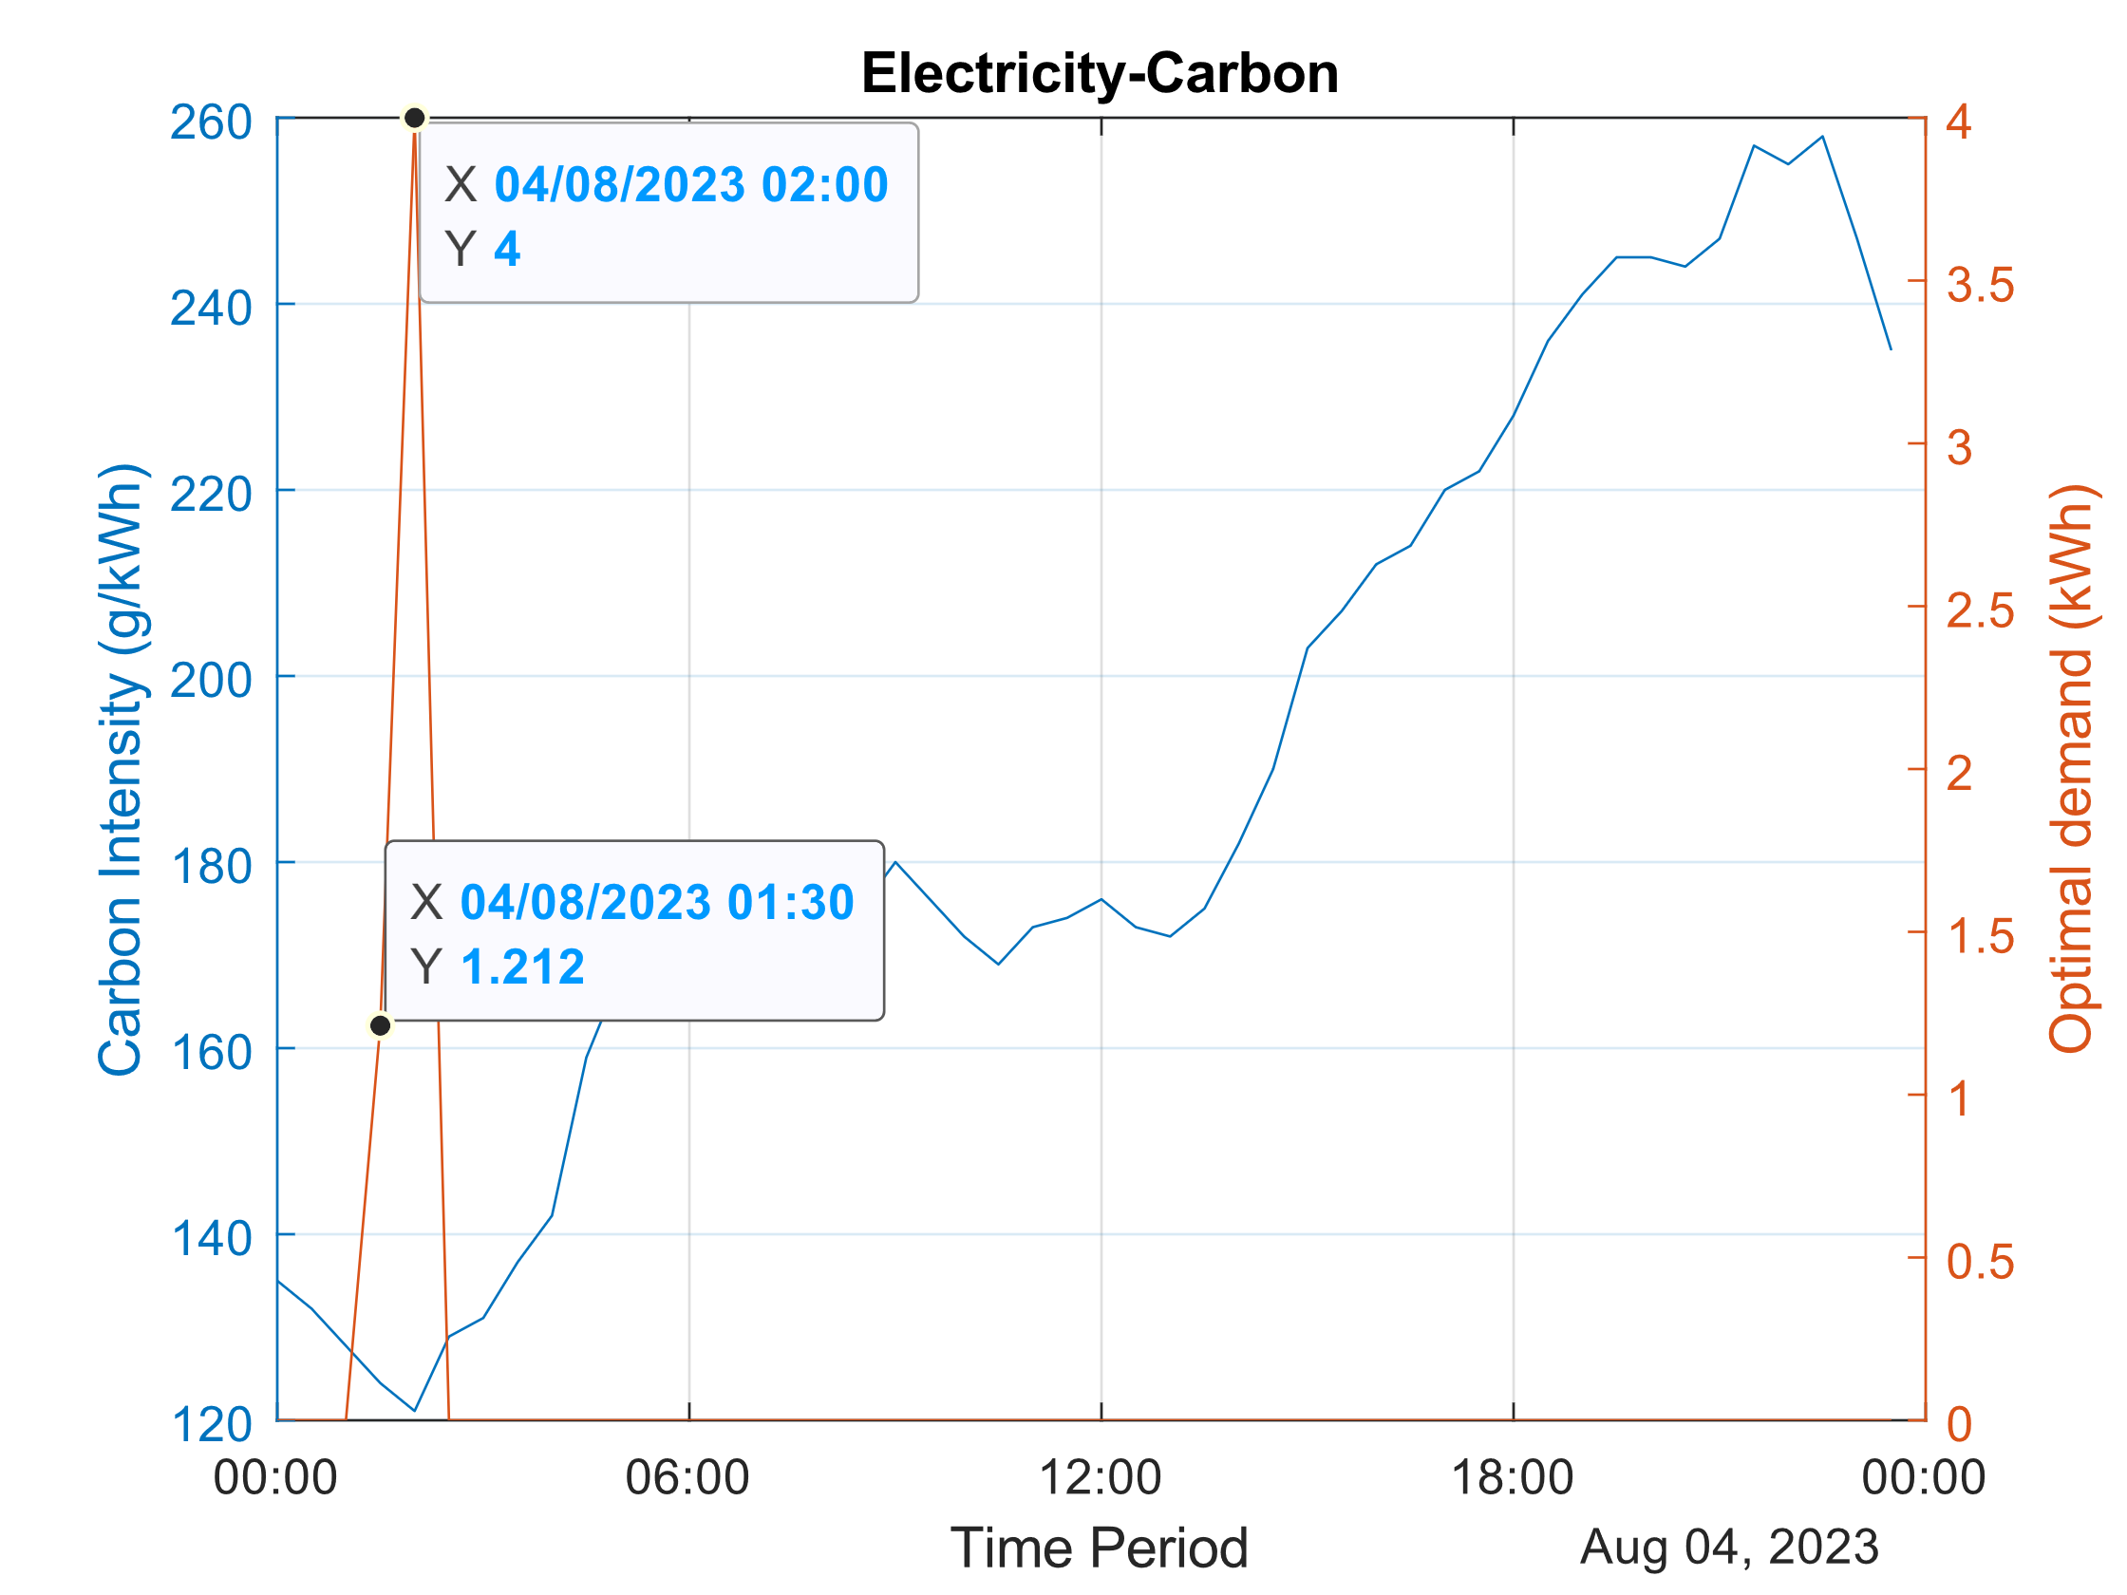

Figure 2: Optimising electricity carbon emissions Figure 3: Optimising gas carbon intensity

Although optimal, these solutions are impractical due to their inconsistency with load trends driven by the daily routines of consumers. These trends heavily constrain a relaxed model since consumers will likely opt to maintain their schedules with minimal deviation.

# Modelling Reality with Demand Response

Incorporating demand response mathematically involves the addition of the following constraint:

(4a)

is a real number between 0 and 1, which models the degree of flexibility the customer is willing to deviate from nominal use. As approaches 1, the problem converges towards the relaxed formulation of (1). In this example, .

## Test and Results

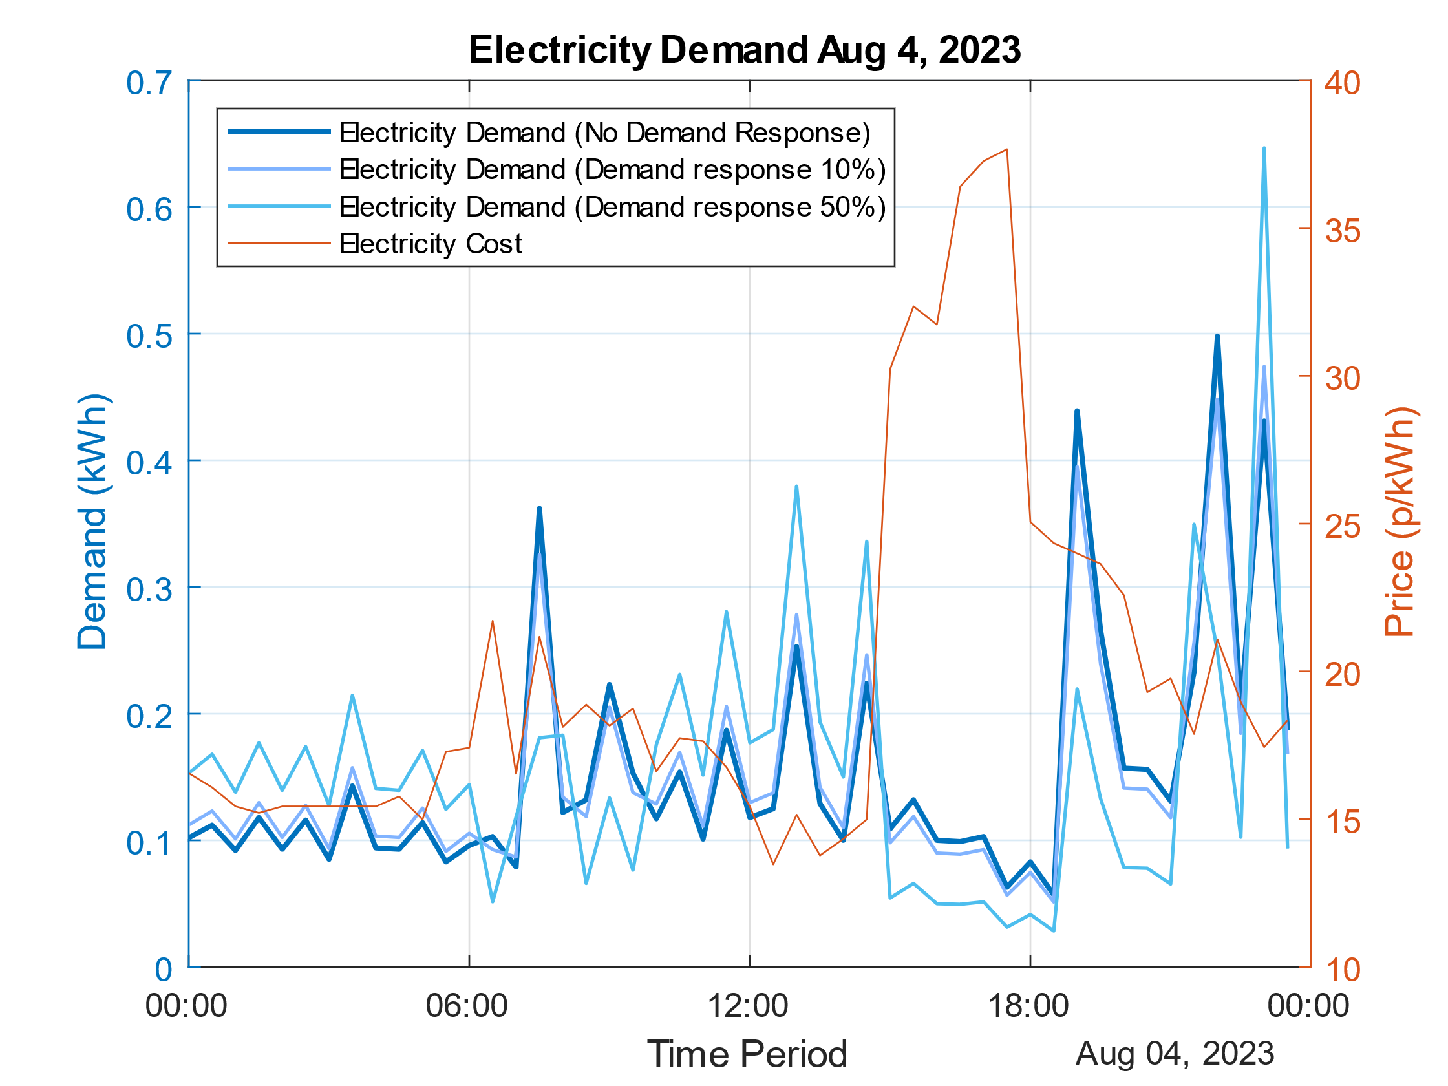Increasing the demand response optimises costs for customers by shifting peaks to low demand areas. However, as Figure 5 shows through the demand peak at 22:00, this neglects the availability of renewables and thus carbon intensity (Figure 2) since photovoltaic sources will be limited at this time. Additionally, this new global maximum ‘spike’ may be problematic for faults and grid stability. This emphasises the challenges of optimising cost and carbon intensity for network regulators.

|  |  |
| --- | --- |
| Flexibility (%) | Savings (p) |
| 0 | 0 |
| 5 | 1.32 |
| 10 | 2.64 |
| 25 | 6.61 |
| 50 | 13.21 |

Table 3: impacts of flexibility

# Discussion

Figure 5: Electricity demand response

With the UK pushing towards its Net-Zero goals, an increasing number of things are becoming electrified such as heating, cars and household appliances. As generation tends towards localised, intermittent, renewable alternatives there is becoming a large discrepancy between supply and demand, especially at peak times. It will be crucial for customers to be more flexible in their electricity usage to compensate for this mismatch in supply and demand. Customers shifting their usage to times of less demand allows them to reduce their carbon footprint and save money as there is a correlation between electricity price and carbon intensity. This is evidenced in Table 2, where optimising for carbon intensity yields savings of 9.2 p. This is because renewable energy, aside from the costs of infrastructure and operation, is free. Figures 2 and 3 do not fully support the general correlation trend between carbon intensity and cost of electricity. This could be because weather is non-deterministic and there is only a one-day sample size, motivating a case for future study.

# References

[1] W. A. Bukhsh, C. Zhang, and P. Pinson, “An Integrated Multiperiod OPF Model With Demand Response and Renewable Generation Uncertainty,” IEEE Transactions on Smart Grid, vol. 7, no. 3, pp. 1495–1503, May 2016, doi: <https://doi.org/10.1109/tsg.2015.2502723>,

[2] C. Helm and M. Mier, “On the efficient market diffusion of intermittent renewable energies,” Energy Economics, vol. 80, pp. 812–830, May 2019, doi: https://doi.org/10.1016/j.eneco.2019.01.017.